Board of Directors Meeting
January 4, 2018
5:30 pm

Agenda
- Call to Order and Welcome

- Consent Agenda
- Minutes of November 21, 2017 Board Meeting
- Director’s Report
- Program Dashboard
- 2018 Nominations
- 2018 Payment Authorization
- Account Signers

- Treasurer’s Report

Minutes of MacRostie Art Center Board of Directors Meeting
November 21, 2017

Present: Aaron Squadroni, President
Angela Ledding, Vice President
Bruce Bartos, Kathy Gebhart, Molly Miskovich, John O’Leary and Kassandra Tuten

In Attendance: Katie Marshall, Executive Director

Apologies: Susan Clandon, Stacy Holl and Katie Tierney

- Call to Order and Welcome
The meeting was called to order at 5:03 p.m. at MacRostie Art Center.

- Consent Agenda
- Minutes from the October 17 Board of Director’s meeting
- Directors Report
- Program Dashboard

Kathy moved to approve consent agenda, Bruce seconded, and it passed.

- Treasurer’s Report
Katie Marshall provided a YTD financial report for 2017, noting accounts are fairly similar to last year, if not currently exceeding. It was noted that the gross profit is currently a little behind, but that will be rectified in December, which is a successful month for consignment sales. It was suggested that the MAC find a means for tracking in-kind donations made to the organization. It was also mentioned that the budget for grants will not be met, although the MAC did receive all operating grants applied for. Molly noticed a potential error in the report under the tab “Change” for COGS.

Bruce moved to receive Treasurer’s Report, Molly seconded, and it passed.

- Strategic Development
Leadership and Organizational Culture – It was noted that the attending board members felt the MAC was doing well in this area.

- Other Business
- 2018 Capital Projects: A revised proposal from Hawk Construction concerning renovation work on the roof was discussed during the meeting. The grand total for the contract amount is $115,122, and includes roofing, plumbing and mechanical, and labor. Possible funding sources, including resources from grants, reserve funds, the City of
Grand Rapids, and a possible pilot lending project were discussed. Angela moved to receive the proposal and to move forward with the project, Molly seconded, and it passed.
B. 2018 Budget – An update was provided by Katie. John moved to receive the budget, Bruce seconded, and it passed.
- Board member resignation – Nicole Lehtinen has resigned from the board due to other obligations, and Mollyann McCann has offered a temporary resignation until after her maternity leave. It was agreed that Mollyann should continue with the board after that time.
D. 2018 Nominations – Molly Miskovich was unanimously voted back onto the board after
a roll call vote. It was noted that there are currently two openings on the board, with some possibilities discussed during the meeting, including reaching out to past board members who have not served in some time.

Bruce moved to adjourn at 5:51 p.m., Molly seconded.

Submitted by: Kassandra Tuten

Director’s Report – December 19, 2017

1. Staffing & Volunteers
- Kayla has been promoted to Gallery Director and David has been given a title upgrade to Education Director.
- MAC is hiring a part time Communications Coordinator – deadline to apply is Dec 22.
- Shout-out to MAC staff—ALL our metrics in the Program Dashboard (next page) are up from last year. Exhibit sales, Art Shop sales, and class registrations. Way to go!

2. Grants
Pending
- Blandin Foundation Committed Connections Grant (2 years) - $40,000/yr
- McKnight Foundation Operating Support Grant (2 years) - $20,000/yr
- Shavlik Family Foundation Grant - $10,000 for an arts technology lab

3. Sponsorships/Exhibitions
- 2018 sponsorship packet has been sent to past sponsors. 19 of 24 exhibits filled for 2018 – only 5 to go!
- MAC Board sponsorship for 2018?

4. Fundraisers/Events
- Wreath Auction raised $1,725!
- Year-end letter was mailed on Dec 12.

5. Partnerships
- What’s Left exhibit is in Hopkins until January. Katie is speaking for an adult education class on Dec 17. A current schedule and press can be found at www.whatsleftmn.com
- MAC is meeting with teaching artists Lea Friesen and Aaron Squadroni and ISD #318 administrators to begin planning a residency with all 4th grade classes to take place in the spring of 2018.
- MAC and Itasca Life Options have started work on the Arts Access grant project which includes expanded classes and field trips to other arts organizations serving developmentally disabled adults.

6. Education
- Spring 2018 classes have been scheduled. We are switching from online registration through Active.com to registration on our own website. We’re also unveiling a new catalog for classes, exhibitions, and artist opportunities.

7. Volunteer Needs
- January Reception: Friday, January 5 (sign-up at meeting)
- Organizing a First Friday volunteer corps. Anyone want to take this on?

MACROSTIE ART CENTER – PROGRAM DASHBOARD
November 2017

EXHIBITIONS

Exhibit Sales Nov 2017 Nov2016 YTD 2017 YTD 2016
$1,087.80 $999.00 $15,534.17 $12,605.47

EDUCATION

Payments – November 2017 Payments – YTD

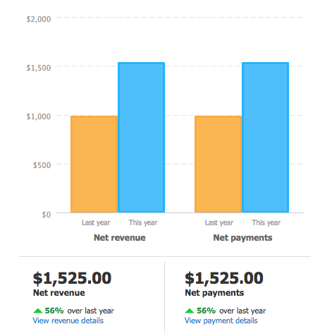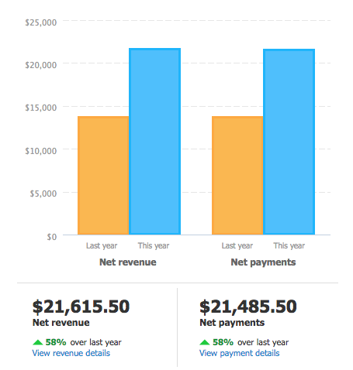

Registrations – Fall Sessions YTD (compared to all fall registrations for 2016)
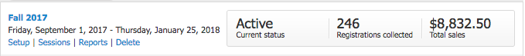
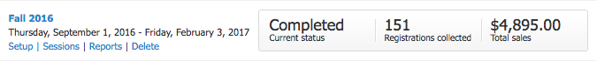

ARTIST SERVICES

Art Shop Sales Nov 2017 Nov 2016 YTD 2017 YTD 2016
$4,752.79 $4,631.24 $31,181.21 $28,269.16

Art Shop Variety
New Art Shop work received in Nov: 38 artists
New Art Shop artists signed in Nov: 5 artists

2018 Board Nominations

Approval of Aaron Olson-Reiners to vacant board seat for term January 2018 – December 2020

Approval of 2018 Executive Committee as recommended by current Executive Committee:
President: Angela Dynkavitch
Vice President: Stacy Holl
Secretary: Kassandra Tuten
Treasurer: Katie Tierney

2018 Account Signers

Approval to add 2018 Board President Angela Dynkavitch and Secretary Kassandra Tuten as signers to all Grand Rapids State Bank accounts and remove Aaron Squadroni (past chair). Katie Tierney (Treasurer), and Katie Marshall (Executive Director) will remain as signers.

2018 Payment Authorization

The MacRostie Art Center Board of Directors authorizes payments to the following entities during Fiscal Year 2018 (January 1 – December 31, 2018):

Annual Vendors
Chamber of Commerce (member dues)
KAXE (member dues)
Mail Chimp (email marketing)
Minnesota Citizens for the Arts (member dues)
Minnesota Council of Nonprofits (member dues)
Philadelphia Insurance (Directors & Officers Insurance)
SFM (Workers Comp Insurance)
West Bend Mutual (Liability Insurance)

Monthly Vendors
Benders Shoes (shared waste disposal)
Blue Cross Blue Shield (health insurance)
MDI Hired Hands (cleaning)
Glorvigen, Theis, Lind & Co (accounting)
Grand Rapids Herald Review (advertising)
Grand Rapids Public Utilities (electric and water)
Minnesota Energy Resources (natural gas)
Paul Bunyan Communications (telephone & internet)
Rapids Printing (postcards – occasional letterhead/envelopes/rack cards)
US Postal Service (postcard mailing and stamps)
Xerox (copier lease)

Contractors – Authorized for repairs only. New projects or equipment require approval.
Nelson Roofing
Quality Refrigeration (HVAC)

Employees and contracted teachers

Payments to vendors that are not listed above and which are over $200 must be approved by the Executive Committee.

Approved by the Board of Directors
Date:

